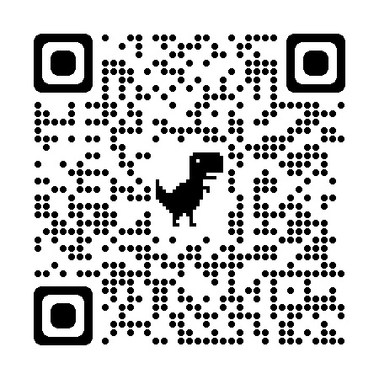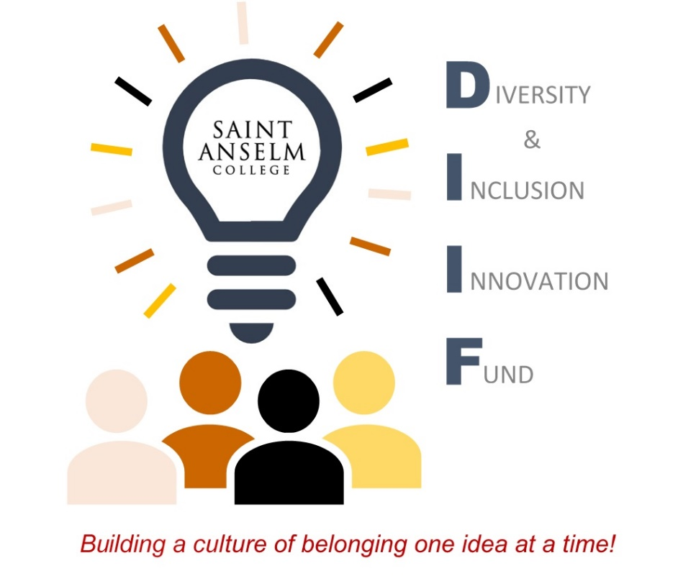

**Let US help you put your ideas into action!**

Apply for the Diversity & Inclusion Innovation Fund **TODAY!**  
 **At A Glance:**

* Eligibility: all faculty, staff, monastic, and student community members.
* **Typical grants range from $500 to $2,500**
* Submission Deadline: **Friday, March 31**, for fall 2023 awards.

**Upcoming DIIF Information Sessions:**

* *Friday, March 3, from 12:30 – 1:30 p.m., Jean Student Center.
* Thursday, March 9, from 4:00 – 5:00 p.m. via [Zoom](https://anselm.zoom.us/j/93588809621?pwd=b25lL0VvNmdKcUNETUhCQTlDN3c4Zz09).
* *Monday, March 13, from 12:30 – 1:30 p.m., Coffee Shop.

***NO RSVP NEEDED – *Just stop by, get the info, and grab a treat!***

**OR visit the Diversity & Inclusion Innovation Fund webpage at:** [**https://www.anselm.edu/about/diversity-and-inclusion/innovation-fund**](https://www.anselm.edu/about/diversity-and-inclusion/innovation-fund)

**Questions?**

* Questions regarding project consultation may be directed to Dr. Ande Diaz at [adiaz@anselm.edu](mailto:adiaz@anselm.edu) / Submission questions may be directed to Paro Pope at [ppope@anselm.edu](mailto:ppope@anselm.edu)

What does diversity and inclusion look like to you?

“Building a culture of belonging one idea

at a time!”