Diversity & Inclusion Innovation Fund - Request for Proposals (RFP)

About
Diversity and Inclusion Innovation Fund is a program that supports faculty, staff, monastic and student community members in the development of a project that will advance diversity and inclusion (see definitions below).

Purpose
To incentivize Saint Anselm College community-based initiatives that will speed campus improvement in the area of diversity and inclusion. Funds indicate a targeted, institutional investment designed to encourage cross-campus collaborations to improve diversity and inclusion for long-term community growth. Such investment and collaboration flow from our Catholic and Benedictine values.

At A Glance
• Eligibility: all faculty, staff, monastic, and student community members.
• Application deadlines: once per fall and spring semester.
• Duration: one semester or one academic year
• Typical grants will range from $500 to $2,500.

Administration and Selection
The funds are administered through the Chief Diversity Officer (CDO), Dr. Ande Diaz. The review committee is appointed by the CDO and chaired by a member of the President’s Committee on Diversity and Inclusivity (PCDI) and includes faculty, staff, monastic, and student community members.

Selection Criteria
The Diversity Innovation Fund is awarded through a competitive grant application process. Not all projects will be funded. PCDI places a high priority on projects and initiatives designed to assist the college realize its mission as a Catholic, Benedictine, liberal arts institution with projects that work toward sustaining an intentionally inclusive environment. In addition, successful proposals will involve collaboration between or among groups within the campus community. Faculty, staff, monastic, and student community members are eligible to receive funds.

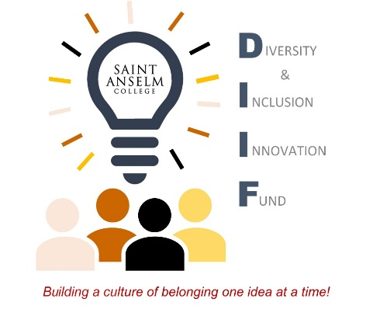
The selection committee invites grant proposals that advance inclusion in light of the college’s mission in one or more of the following areas:

- Recruitment and retention
- Dialogue and civil discourse for social equity
- Curricular/co-curricular collaborations
- Enhanced student learning within and beyond the classroom
- Integration of local/global diversity
- Faculty research and teaching re: diversity
- Students’ understanding of collaboration and inclusion
- Faculty, staff, monastic, and student partnerships

Submission guidelines:
This year’s deadline for submission is Friday, March 31, 2023 for fall 2023 awards. Announcements of recipients of the innovation funds will be made in May to publicize their upcoming initiatives to the community. Note: All student-initiated proposals need contact information and sign-off by an academic department or administrative office for funding disbursement.

- Please provide estimate breakdown of how funds will be used.
- Please specify exactly how the proposal meets the criteria for funding project.
- Please describe how you will assess the success of the proposed initiative.

Submit proposals with the application cover sheet via email to Diversity & Inclusion Innovation Fund @ diif@anselm.edu.
Questions regarding submission details may be directed to Paro Pope at ppope@anselm.edu.
Questions regarding project consultation may be directed to Dr. Ande Diaz at adiaz@anselm.edu .

Diversity – includes individual and group/social differences. [The Saint Anselm community is inclusive of individuals who reflect a broad range of social identities including the following: Socioeconomic Class, Race, Ethnicity, Gender, Sexual Orientation, Disability, Religion, Politics, National Origin, and First Generation]

Inclusion -The active, intentional, and ongoing engagement with diversity.

